Citation: Siraj-Blatchford, J. & Brock, L. (2016) Schemas: Free Flow Play (Part 1), Early Years Educator Magazine, January, download at: http://dx.doi.org/10.12968/eyed.2016.17.10.18
Series title: Putting the Schema back into Schema Theory and Practice
Prof John Siraj-Blatchford and Lynnette Brock
Part One: Schemas: Free Flow Play
This article is the first of a series of three articles that present some of the fundamental principles of child development and learning in a new, and we hope a much clearer way for practitioners and students of early childhood care and education to follow. Most of the theoretical ideas that will be presented are widely accepted and promoted by early childhood academics, and they are backed up by strong empirical evidence. The novelty in our approach should be recognised as much less in any selection or identification of the principles themselves, but rather in the manner in which we have chosen to combine and present them. Developmental psychology, just like every other scientific discipline provides theoretical models that are intended to help us understand our observations. They may be considered more or less to approximate or represent reality, but their value is most significantly in their pragmatic usefulness in allowing us to make predictions. In this particular case our model has been developed with the intention of improving our educational practice. To this end, in this first article we provide a summary account of the cognitive processes of learning. We introduce the key terms that describe the what is involved, and we apply these to explain why it is that free flow play ‘works’ in practice, and what role there is for adults educators and carers in supporting it. Next month, in part two of the series we will be; ‘Putting the Schema back into Schema Theory and Practice’, and then in the final instalment we will be explaining how emergent literacy works with; “Emergence and the EYFS curriculum”.

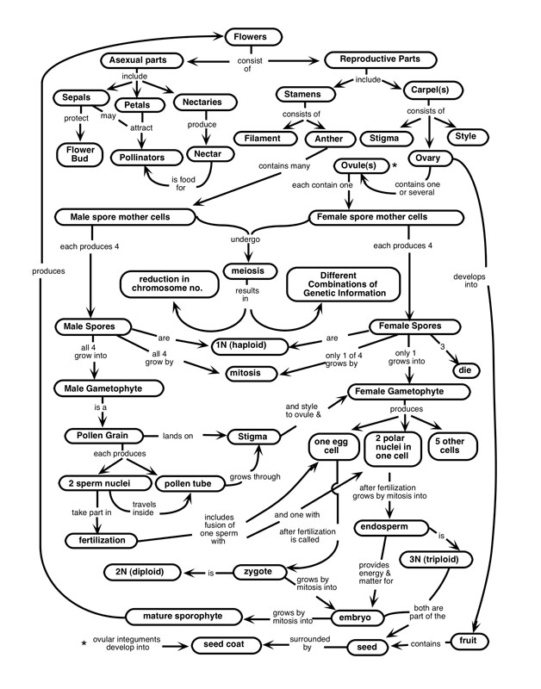
To begin at the beginning with child development and learning, it is important at first to consider how we come to acquire and apply a knowledge of the world around us. One of the most common assumptions is that we come to hold some figurative form of representation of the objects around us. Since Piaget, developmental psychologists have commonly refered to these figurative representations as Schemas’. The most simple form of learning provides a one-to-one correspondence between some stimulus and its schema representation in the mind. Piaget referred to such learning as ‘reproductive’ and Vygotsky as ‘empirical’, and then moved their attention on to consider the much more challenging subject of conceptual learning. To take a simple example, we can consider the case of flowers. At an early stage of our learning about flowers we may have seen roses, lily’s and/or other varieties and used a single image or the word flower to represent them. We might also use the word flower, and the name of a particular flower such as a rose interchangeably, but at some point in our social and cultural interactions we will be encouraged to differentiate between different flowers, to note particular characteristics and to recognise that the word ‘flower’ provides an abstract higher order category or concept that includes all of those particular varieties that we have learnt about. Our life experiences, conversations and observations of other people around us will then lead us to elaborate upon this structure of representations in our mind. New varieties will be added to the structure such as the blossom that we see on trees, and we may learn that flowers support the reproduction of plants, that they are brightly coloured to attract insects who help the plant in dispersing its seeds. Connections will therefore be made to concepts developed related to other areas of our learning about the natural world and we may add cognitive representations of different parts of the flower, of petals, stamens, pollen… A good way of imagining the emerging cognitive structure is in terms of a mind ‘map’ which can become extremely complex and elaborate when we take a special interest and study any particular subject (Illustration: Part of the ‘mind map’ of a Botanist).

In our next article we will discuss Chris Athey’s (2007) contribution to Schema theory and practice in early childhood education in more depth, but for the time being it is sufficient to note that in her work she identified a distinction that was made by Piaget between cognitive 'schemes' that provide the child with operational knowledge, and children's figurative 'schemas' as described above. 'Schema practice', might now be considered to involve the practitioner in first identifying and then encouraging the child's 'patterns of repeated behaviour' into which new experiences are then 'assimilated and gradually co-ordinated' (Athey 1990, p37).But Athey argued that research progress was being hindered by an ambiguity in the use of the terms and that the fundamental difference between operative and figurative thinking was ‘worthy of further study’ (op cit, p113-14). A significant contribution towards clarifying this distinction between schemas and schemes has subsequently been made by Gibson (1969) who argues that we only perceive objects or events through their ‘affordances’: or what we can ‘do’ with them. Operative Schemes are therefore fundamental to perception. A child may have a figurative scheme for an aeroplane, but it only when the child perceives what an aeroplane does that it is possible for them to differentiate it from other objects, such as a car or a truck. The best way to understand schemes and schemas may be to consider them like ‘two sides of a coin’, or two distinct qualities one of form, and the other of content, that are captured in each cognitive construction.

Applying schemes and schemas to explain Free Flow Play
As Laevers’ (1999) has noted, in free flow play the child is complete immersed in the activity, they are totally involved, and they experience a sense of fulfilment. As Bruce (2004) has noted, free flow play provides opportunities for children to ‘try out their most recently acquired skills and competences, as if celebrating what they know’ (p132). In cognitive terms, this is precisely what the child is doing, they are playfully ‘trying on’, just for the fun of it, different schemas to see how they fit (or not) different schemes, and they are trying out different schemes to see how they work (or not) with different schemas. This is a powerful process in cognitive development described by Piaget as assimilation, and it’s all about making connections in the mind, it’s about fitting schemes and schemas together. While we might consider the question of which comes first an example of the ‘chicken and egg’ paradox, play clearly does require some prior knowledge acquisition, what Piaget referred to as schematic ‘accommodation’. As Furth (1969) has explained:

"The child who re-enacts a scene from yesterday represents through symbol formation the event which was yesterday present to him through object formation…It gives food to his growing operative thinking which otherwise would be limited to perceptual events of here and now." (Furth, 1969, p89)

Free flow play may be considered ‘seeded’ by the child’s prior learning of a scheme or schema. This may have occurred through the child’s observation and imitation of others or through direct instruction, but it is important to recognise that the child’s learning will remain incomplete if they are not provided with the opportunity to play with the new ideas, to identify the strengths and limitations of the schemes and schemas, and to own them for themselves. This is what we mean when we say that learning is essentially a creative and child centred process. As Vygotsky noted, what we supporting through play are the development of cognitive functions that vare still in an embryonic state: “These functions could be termed the ‘buds’ or ‘flowers’ of development rather than the ‘fruits’ of development”.(Vygotsky, 1935, p. 42).

The following diagram represents the cognitive processes involved, described by van Oers (1998), as a process of ‘progressive continuous re-contextualisation’, where:

“A child’s play is not simply a reproduction of what he has experienced, but a creative reworking of the impressions he has acquired” (Vygotsky, 1987, p11).

The adults role, as the outer cycles suggest, is to provide at times the schematic resources that the child needs to play with, This may be done systematically, as in the case of Montessori presentations, or much less formally in providing curriculum focused activities for the as an chid individual or in a small group. The adult also has a role in providing the opportunities for the child to earn from others, and to support and encourage the child to continue playing within their zone of proximal flow.

Play within the Zone of Proximal Flow

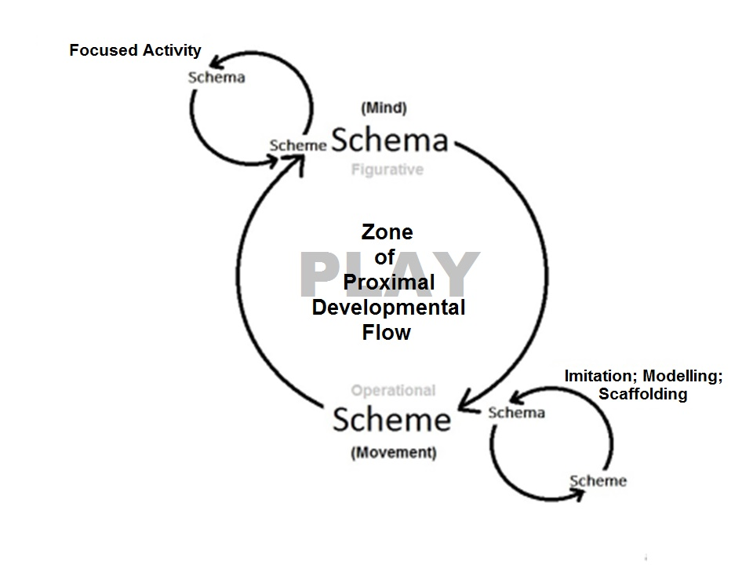
We have adapted Vygotsky’s concept of the zone of proximal development to describe free flow play as providing a zone of proximal flow where the child’s learning is scaffolded by their own independent recall rather than by the scaffolding of an adult or more capable peer.

People sometimes seem to suggest that there are two different emphasis we can place of early childhood education. We could emphasise ‘learning things’ or we could emphasise creativity or ‘learning what can be done’ with things. Already when we put the apparent dichotomy in these terms we can see the contradiction. We need to have learnt things if we are to be creative with them. The common practice of applying the term schema to child behaviours that both Piaget and Athey clearly regarded to be operative schemes may have served to limit our understanding of children's learning and, even more crucially, our understanding of how best to scaffold it.

John Siraj-Blatchford in an honorary Professor of Early Childhood Education at the University of Plymouth and Lynnette Brock is a lecturer and researcher at the Montessori Centre International College in London. Further information may be found at: www.schemaplay.com

References
Athey, C (1990; 2007) Extending Thought in Young Children, London: Sage Publications
Bruce, T (2004) ‘Playmatters’ in Abbott, L and Langston, A (eds) Birth to Three Matters: supporting the framework of effective practice, Open University Press, Maidenhead
Furth, H.G. (1969) Piaget and Knowledge:Theoretical Foundation, USA: Prentice-Hall
Gibson, E. J. (1969). Principles of perceptual learning and development, New York: Meredith Corporation
Piaget, J (1969) The Mechanisms of Perception. New York: Basic Books
Siraj-Blatchford, J., and Brock, L. (2015) Taking play more seriously: A Montessori approach to understanding Free Flow Play, Research Brief, presented at TACTYC Conference, Birmingham, November
Van Oers, B. (1999) Teaching Opportunities in Play, in Hedegaard, M & Lompscher, J., (Eds) Learning Activity and Development, Aarhus University Press, Aarhus
Vygotsky, L. (1962) Thought and language. Cambridge, MA US, MIT Press

