Education phase | Curriculum emphasis | SSAF formation being cultivated | Accumulating civic meanings
EYFS | Shared routines, scarce resources, snack time, tidying, caring for plants/animals, turn-taking games, building together, stories of helping and repair. | Force, resistance, release, moderation, early reciprocity. Children repeatedly experience that action affects others and that restraint can keep shared activity alive. | Citizenship as belonging, care, inclusion and repair. Children can take pride in being part of “how we look after things and each other here.”
Key Stage 1 | More deliberate use of roles, teams, shared tasks, class responsibilities, fair distribution, simple votes, collaborative construction, environmental care. | Reciprocity, compromise and shared practice. The experience of others as co-participants and shared arrangements make common activity possible, especially where different interests must be accommodated. | Citizenship as fairness, helping, sharing, responsibility and voice.
Key Stage 2 | Class councils, group projects, common goods, rule-making, community links, local environmental action, conflict repair, stories of rights and responsibilities. | Rule-governed coexistence. Children begin to see rules and routines not merely as commands, but as arrangements that allow people to live and work together. | Citizenship as participation in a shared order: rules, roles, responsibility, fairness, inclusion and care for common resources.
Key Stage 3 | Public issues, disagreement, justice, inequality, representation, law, democracy, media, identity, sustainability, community conflict. | Reflective citizenship. Children begin to ask who is included, who decides, who benefits, what is fair, and what should change. | Citizenship as judgement about shared arrangements. Common life is made, contested, repaired and improved.
Key Stage 4 | More complex civic dilemmas: rights in tension, protest, law and justice, climate responsibilities, migration, economic scarcity, competing public goods. | Systemic civic reasoning. Learners can begin to hold multiple interests, institutions and consequences in view. | Citizenship as responsible participation within complex systems, not merely personal kindness or rule-following.
Key Stage 5  16–19 | Diplomacy, conflict resolution, international relations, industrial relations, climate negotiations, peace processes, constitutional conflict, ethical disagreement. | Détente becomes conceptually available. Learners can understand that opposed parties may reduce tension without resolving all disagreement. | Citizenship as non-escalatory coexistence: restraint, accommodation, negotiation and maintenance of a shared world.
Further Education | Workplace citizenship, unions and management, professional ethics, community responsibility, practical democracy, resource allocation. | Applied civic judgement. Concepts are tested in real institutional settings. | Citizenship as participation in economic, occupational and community systems.
Higher Education | Political theory, sociology, law, education, history, economics, international relations, ecology, ethics, systems thinking. | Critical citizenship. Learners examine the structures, histories and power relations behind civic arrangements. | Citizenship as critical participation in institutions and knowledge systems.
Postdoctoral / advanced research | Theory-building, policy critique, institutional design, conflict analysis, educational research, democratic innovation, ecological and geopolitical systems. | Meta-civic analysis. Citizenship and détente become objects of theoretical reconstruction. | Citizenship as the design, critique and renewal of shared systems.

Citizenship education should be understood as an education for participation in the repair, maintenance and renewal of civil society, understood as the shared cultural achievement of peaceful, just, inclusive and sustainable common life. It requires the cultivation of children’s real capabilities to belong, care, deliberate, question, cooperate, dissent, repair, and help sustain the social and ecological arrangements on which peaceful coexistance depends. Such a perspective stands in stark contrast to approaches that prioritise the transmission of civic knowledge and/or the production of compliant behaviour,
The table traces how increasingly complex civic meanings may become available through repeated participation in culturally organised practices: shared meals, team games, sibling negotiation, classroom routines, collective play, scarce resources, environmental care, stories, disputes, repairs and agreements. In each case, the child is not simply receiving social rules from outside, but is participating in a triptych relation involving the child, others/community, and the artefact–institutional environment.
On this account, early sensory-motor schemes of force, resistance, release and moderation provide the operative ground from which later civic meanings can be canalised. These pathways are progressively reorganised through reciprocal activity, shared practice, rule-governed coexistence and affectively charged experiences of belonging, fairness, responsibility, voice and repair. Citizenship is therefore understood not as a late abstraction, but as a developing conception of participation in a shared social world whose arrangements must be sustained, negotiated, questioned and restored.
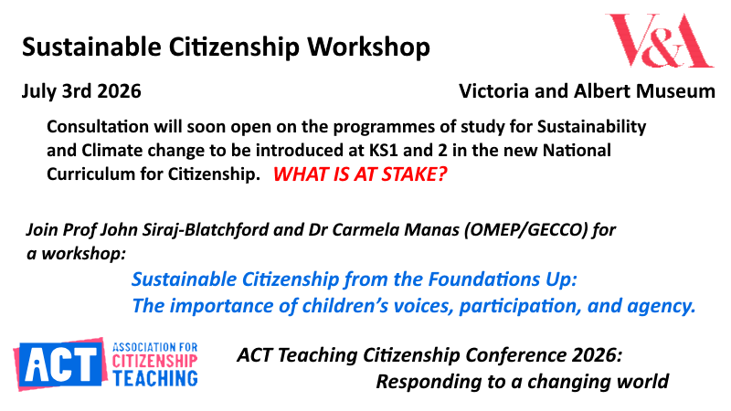
Citizenship requires being able to understand, question, sustain, repair and reshape the arrangements through which common life is organised. We must avoid confusing the ‘participation’ that is suggested with mere compliance. The developmental aim is not simply that children learn to fit existing arrangements, follow rules or cooperate on demand, but that they gain real opportunities to belong, and the learn to contribute, question, object, repair and help reshape the practices through which common life is organised. Citizenship requires the active maintenance and renewal of civic order.
Détente is identified as an example of a more advanced civic and diplomatic formation within this trajectory: the recognition that opposed parties may deliberately reduce tension and preserve coexistence without requiring full agreement.
Progression = cultivating the SSAF conditions for civic understanding from the start, then progressively re-presenting them at higher levels of conceptual, affective and institutional complexity

Siraj-Blatchford, J. https://johnsb.org.uk/wp-content/uploads/2026/06/From-Schema-to-Cognitive-Pathway2.pdf
Garcia Manas, C., and Siraj-Blatchford, J. https://johnsb.org.uk/wp-content/uploads/2026/06/EECERA26.pdf

